

K.D.K. College of Engineering Nagpur
Department of Computer Science and Engineering
DEPARTMENTAL FORUM 2025-26

PICSEL COMMITTEE
(Panel In Computer Science & Engineering Learners)

Positions | Name | Year
President | Amartya Choubey | 4th Year
Vice-President | Ankit Chikhlonde | 4th Year
Executive Vice President | Ashwini Galhat | 4th Year
Technical Vice President | Mohit Parteti | 4th Year
Secretary | Atharva Dayalwar | 4th Year
Treasurer | Vinod Balla | 4th Year
Treasurer | Karan Soyam | 4th Year
Joint Treasurer | Rudresh Dodke | 4th Year
Joint Treasurer | Amit Gond | 4th Year

Joint Secretary | Kumkum Laveti | 4th Year | Akanksha Asutkar | 3rd Year
Joint Secretary | Kumkum Laveti | 4th Year | Aditya Diware | 3rd Year
Joint Secretary | Ishwari Khandwe | 4th Year | Aayush Raulkar | 3rd Year
Joint Secretary | Ishwari Khandwe | 4th Year | Vedangi Londhe | 3rd Year
 |  |  | Atul Tandekar | 3rd Year

Event Head | Khushi Bodakhe | 4th Year | Dhiraj Sarate | 3rd Year
Event Head | Khushi Bodakhe | 4th Year | Gaurav Aswale | 3rd Year
Event Head | Himanshu Kamble | 4th Year | Sanika Raut | 3rd Year
Event Head | Himanshu Kamble | 4th Year | Anandi Girde | 3rd Year
Event Head | Tanvi Samarth | 4th Year | Janhvi Ingole | 3rd Year
Event Head | Tanvi Samarth | 4th Year | Kalyani Dharmashahare | 3rd Year
Event Head | Harshit Pachbudhe | 4th Year | Pranay Mule | 3rd Year
Event Head | Harshit Pachbudhe | 4th Year | Swastik Padole | 3rd Year
 |  |  | Adnan Shaikh | 3rd Year
 |  |  | Kiran Kharat | 3rd Year
Creative Head | Om Lohakare | 4th Year | Bhoomika Ushekwar | 3rd Year
Creative Head | Sanskruti Telang | 4th Year | Darshani Kakde | 3rd Year
Creative Head | Tejaswini Thakare | 4th Year | Janvi Konkamwar | 3rd Year
Creative Head | Mansi Katre | 4th Year | Vishwajeet Bal | 3rd Year
Creative Head | Aishwarya Tekode | 4th Year | Himanshu Dhanwat | 3rd Year
 |  |  | Bhupendra Gajbhiye | 3rd Year
 |  |  | Kunal Katre | 3rd Year

Publicity Head | Anisha Katkade |  | 4th Year
Publicity Head | Kaushik Shetkar |  | 4th Year
Website Head | Ritish Das | 4th Year | Dhiraj Dhole | 3rd Year
Website Head | Aniket Dhakate | 4th Year | Saniya Lanjewar | 3rd Year
Website Head | Aditi Badhe | 4th Year | Arya Shendre | 3rd Year
Website Head | Rasika Pande | 4th Year | Pratik Zambre | 3rd Year
 |  |  | Dishant Talwekar | 3rd Year

Sports Head | Nishant Ghuse | 4th Year | Krushnam Khandelwal | 3rd Year
Sports Head | Harshal Shende | 4th Year | P. Krishna Suryakant | 3rd Year
Sports Head | Himanshu Dubey | 4th Year | Sunil Kotkar | 3rd Year
Sports Head | Man Gajbhiye | 4th Year | Sushant Swami | 3rd Year
 |  |  | Harshita Rathod | 3rd Year
 |  |  | Anshika Choudhary | 3rd Year

Technical Head | Tejas Umate | 4th Year | Anand Ratnaporkhe | 3rd Year
Technical Head | Rohit Sakharkar | 4th Year | Atul Gonnade | 3rd Year
Technical Head | Sajjan Udar | 4th Year | Hitesh Vaidya | 3rd Year
Technical Head | Rohit Parsode | 4th Year | Kuldip Thakre | 3rd Year

Social Media Head | Harsh Gajbhiye | 4th Year | Yash Lokhande | 3rd Year
Social Media Head | Shraddha Gadiwan | 4th Year | Shreyash Chakrapani | 3rd Year
Social Media Head | Sakshi Muneshwar | 4th Year | Harsh Thubrikar | 3rd Year
 |  |  | Ansh Pawar | 3rd Year

Tech-Magazine Head | Tanushree Patle | 4th Year | Samiksha Milmile | 3rd Year
Tech-Magazine Head | Tanushree Patle | 4th Year | Sejal Kamble | 3rd Year
Tech-Magazine Head | Sahil Madankar | 4th Year | Rutul Parate | 3rd Year
Tech-Magazine Head | Sahil Madankar | 4th Year | Rasika Bandge | 3rd Year

Food Head | Sanket Sute | 4th Year
Food Head | Bhushan Gondane | 4th Year
Sponsorship Head | Prem Maliye | 4th Year
Sponsorship Head | Venkatesh Patil | 4th Year
Committee Advisor | Amit Ghugal | 4th Year
Committee Advisor | Krishna Thakre | 4th Year
Committee Advisor | Anisha Gurmukhi | 4th Year
Committee Advisor | Aparna Badhe | 4th Year
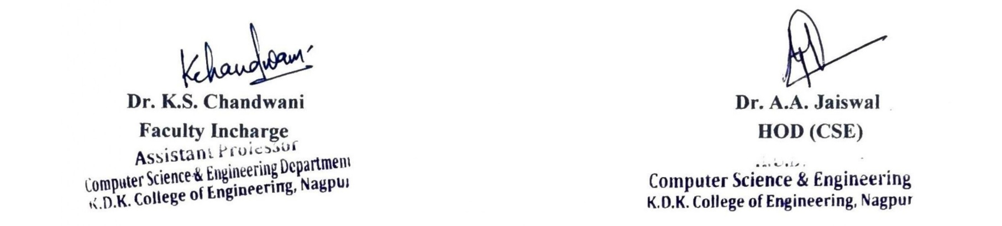

K.D.K. College of Engineering Nagpur
Department of Computer Science and Engineering
DEPARTMENTAL FORUM 2025-26

PICSEL COMMITTEE
(Panel In Computer Science & Engineering Learners)

Principal | Dr. V.P. Varghese
Vice-Principal | Dr. A.M. Badar

Head of Department | Dr. A.A. Jaiswal
Faculty Incharge | Dr. K.S. Chandwani
Event Incharge | Prof. A.P. Nachankar
Event Incharge | Prof. S.A. Satone
Event Incharge | Prof. N.P. Dhuriya
Seminar Incharge | Prof. V.R. Surjuse
Seminar Incharge | Prof. T.H. Mankar
Website Incharge | Prof. S.A. Kurzadkar
Website Incharge | Prof. M.R. Balbudhe
Creative Incharge | Prof. P.A. Kuchewar
Creative Incharge | Prof. P.A. Gharad
Tech-Mag Incharge | Prof. A.M. Kuthe
Tech-Mag Incharge | Prof. D.A. Agrawal
Technical Incharge | Prof. D.W. Wanjari
Technical Incharge | Prof. S.S. Chahande
Sports Incharge | Prof. S.B. Verma
Sports Incharge | Prof. R.M. Thakur
Publicity & Media | Prof. R.R. Shende
Publicity & Media | Prof. P.D. Faye

